EEE 322 PRACTICE QUESTIONS
- Determine the source current and the input impedance for the magnetically-coupled coils below:
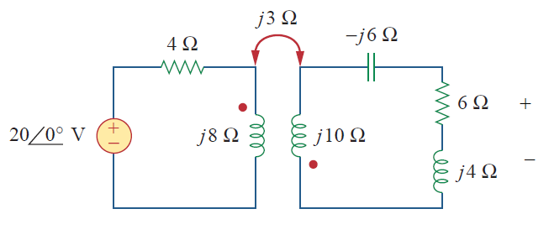
- For the second-order passive lowpass filter circuit below, given R₁ = 2 Ω, R₂ = 5 Ω, C₁ = 0.1 F, and C₂ = 0.2 F, obtain the transfer function $H\left(s\right)=V_{out}/V_{in}$
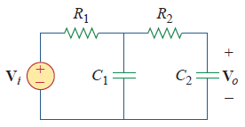
- Determine the mesh currents i₁, i₂, and i₃ in the circuit below:
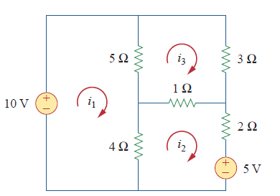
- Two coils L_{1,} L_{2,} connected in series-aiding fashion have a total inductance of 250 mH. When connected in a series-opposing configuration, the coils have a total inductance of 150 mH. If the inductance of one coil (L₁) is three times the other,
- Find L_{1,} L₂ and M.
- What is the coupling coefficient?
- Design a series RLC circuit with B = 20 rad/s and $ω_{o}$=1krad/s. Find the quality factor of the circuit for R = 10 Ω.

- For the circuit below, obtain the transfer function$V_{O}(ω)/V_{i}(ω)$. What type of filter is represented by the circuit; determine the corner frequency? Take R₁ = 100 Ω = R₂, L = 2 mH.
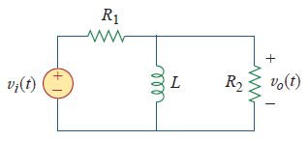
- A parallel RLC circuit has R = 5k Ω, L = 8 mH, and C = 60 µF. Determine:
- the resonant frequency
- the bandwidth
- the quality factor
- In an electronic device, a series circuit is employed that has a resistance of 100 Ω, a capacitive reactance of 5 k Ω, and an inductive reactance of 300 Ω when used at 2 MHz. Find:
- the resonant frequency and,
- the bandwidth of the circuit.
- Find the voltage $v_{o}$ across the 4-Ω resistor in the circuit below:
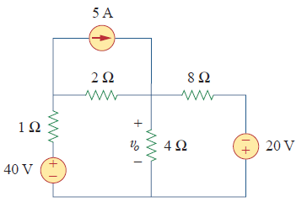
- A series RLC circuit has resistance, R = 12 Ω and inductance, L = 60 mH, calculate:
- the value of C that will produce a quality factor of 50
- ω₁, ω₂, and B
- the average power dissipated at ω = ω₀, ω₁, and ω₂. Take V_{m} = 60V

- A radio receiver has an output resistance of 300 Ω. When connected directly to an antenna system with a characteristic impedance of 75 Ω, an impedance mismatch occurs. By inserting an impedance-matching transformer ahead of the receiver, maximum power can be realized. Calculate the required turns ratio.
- Design a series RLC circuit with B = 20 rad/s and $ω_{o}$=1krad/s. Find the quality factor of the circuit for R = 10 Ω.
- For the circuit below, obtain the transfer function${ V}_{O}(ω)/V_{i}(ω)$. What type of filter is represented by the circuit; determine the corner frequency? Take R₁ = 100 Ω = R₂, L = 2 mH.
- A parallel RLC circuit has R = 5k Ω, L = 8 mH, and C = 60 µF. Determine:
- the resonant frequency
- the bandwidth
- the quality factor
- In an electronic device, a series circuit is employed that has a resistance of 100 Ω, a capacitive reactance of 5 k Ω, and an inductive reactance of 300 Ω when used at 2 MHz. Find:
- the resonant frequency and,
- the bandwidth of the circuit.
- Obtain the mesh-current equations for the circuit below:
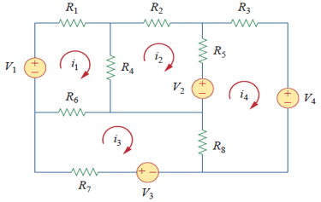

- Find the voltage, V_{o} across the output resistor in the circuit below:
