GLYCOGEN METABOLISM
Glycogen is the major storage form of glucose mainly in the liver and muscle. The concentration of liver glycogen (up to 6%) is greater than in muscle (1%) tissues. However, because muscle tissue comprises a large mass, its total capacity to storage is three to four times that of the liver.
The synthesis, glycogenesis and degradation, glycogenolysis occur via different pathways. Glycogenesis and glycogenolysis are both cytosolic processes.
Glycogenesis
Glycogenesis is the pathway for the formation of glycogen from glucose. This process requires energy, supplied by ATP and uridine triphosphate (UTP). It occurs in muscle and liver
Reactions of Glycogenesis (Figure 1)
1. Glucose is phosphorylated to glucose-6-phosphate catalyzed by hexokinase in muscle and glucokinase in the liver.
2. Glucose-6-phosphate is converted to glucose-1-phosphate by the enzyme phosphoglucomutase.
3. Glucose-1-phosphate reacts with uridine triphosphate (UTP) to form uridine diphosphate glucose (UDP-GIc). The reaction is catalyzed by the enzyme UDP-glucose pyrophosphorylase.
4. By the action of the enzyme glycogen synthase, the C1 of the glucose of UDP-Glc forms a glycosidic bond with C4 of a terminal glucose residue of pre-existing glycogen molecule (glycogen primer), liberating uridine diphosphate (UDP). Thus, pre-existing glycogen molecule must be present to initiate this reaction.
5. In the above reaction, a new α-1,4 linkage is established between carbon atom 1 of incoming glucose and carbon 4 of the terminal glucose of a glycogen primer
6. When the chain has been lengthened to a minimum of 11 residues, a second enzyme, the branching enzyme, transfers a part of the 1,4-chain (minimum length of 6-glucose residues) to a neighboring chain to form α -1,6-linkage, thus establishing a branching point in the molecule (Figure 2). The branches grow by further additions of glucose units and further branching.

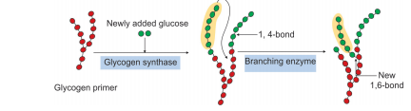
Figure 2: Schematic representation of glycogenesis (mechanism of branching)

Glycogenolysis
Glycogenolysis is the degradation of glycogen to glucose-6-phosphate and glucose in muscle and liver respectively. Glycogenolysis is not the reverse of glycogenesis but is a separate pathway.
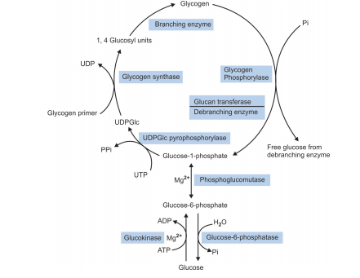
Figure 1: Pathway of glycogenesis and glycogenolysis in the liver
where, UTP = Uridine triphosphate, UDP = Uridine diphosphate, UDPGIc = Uridine diphosphate glucose
Reactions of Glycogenolysis (Figure 1)
1. Glycogenolysis occurs primarily by phosphorolytic breaking of α-1,4-glycosidic bonds of glycogen to yield glucose-1-phosphate and residual glycogen molecule. This process is catalyzed by the enzyme
glycogen phosphorylase. The glucose residues from outermost chain of the glycogen molecule are removed sequentially until approximately four glucose residues remain on either side of a branch point having α-1,6 linkage (Figure 3).
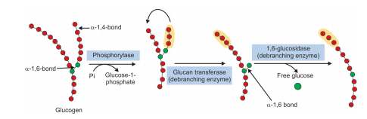
Figure 3: Schematic representation of glycogenolysis (mechanism of debranching)
2. Phosphorolysis cannot continue until the branch is removed. This is accomplished by a debranching enzyme. It has two catalytic activities— glucan transferase and 1,6-glucosidase.
(a) First, it acts as a glucan transferase and transfers three of the remaining residues from one branch to the other. This exposes the α-1,6 branch point.
(b) In the second step, the hydrolytic splitting of the α-1,6 linkages occurs by the action of 1,6- glucosidase. This step releases free glucose. Further splitting of the glycogen can then proceed by the actions of phosphorylase until another branch point is reached. The action of glucan transferase and 1,6-glucosidase are repeated.
The combined action of phosphorylase and debranching enzyme leads to the complete breakdown of glycogen with the formation of glucose-1- phosphate and free glucose (from hydrolytic cleavage of the 1,6-glycosidic bond).
3. Next, glucose-1-phosphate is converted to glucose- 6-phosphate by phosphoglucomutase. This is a reversible reaction.
4. In the liver but not in the muscle, there is a specific enzyme, glucose-6-phosphatase, that cleaves glucose-6-phosphate to glucose and diffuse from the hepatic cell into the blood. As glucose-6-phosphatase is absent in muscle, free glucose cannot be produced from glucose-6-phosphate in muscle. Moreover, glucose-6- phosphate cannot diffuse out of the muscles. Therefore, the muscle cannot provide glucose to maintain blood glucose levels.
Significance of Glycogenolysis and Glycogenesis
The functional role of glycogen differs considerably from tissue to tissue, as we can see in the case of liver and muscle.
(a) In liver
Following a meal, excess glucose is removed from the portal circulation and stored as glycogen by glycogenesis. Conversely, between meals, blood glucose levels are maintained within the normal range by release of glucose from liver glycogen by glycogenolysis.
(b) In muscle
The function of muscle glycogen is to act as a readily available source of glucose within the muscle itself during muscle contraction. The muscle cannot release glucose into the blood, because of the absence of glucose-6-phosphatase that hydrolyzes glucose 6-phosphate to glucose. Therefore, muscle glycogen stores are used exclusively by muscles.
Regulation of Glycogenesis and Glycogenolysis
The principal enzymes controlling glycogen metabolism are glycogen phosphorylase and glycogen synthase which are regulated reciprocally. Regulation of these enzymes involve hormonal and allosteric regulations.
(a) Hormonal Regulation
Epinephrine and glucagon regulate glycogen breakdown and glycogen synthesis. Epinephrine (in liver and muscle) and glucagon (in liver) stimulates glycogen breakdown (glycogenolysis) and inhibits glycogen synthesis (glycogenesis).
(i) Regulation of glycogenesis (Figure 4)
Glycogen synthase is the regulatory enzyme of glycogenesis. It exists in two forms: Glycogen synthase-a, an active or dephosphorylated form and Glycogen synthase-b, an inactive or phosphorylated form. Glucagon in liver and epinephrine in liver and muscle activates adenylate cyclase enzyme that catalyzes the synthesis of c-AMP. c-AMP, in turn, activates c-AMP dependent protein kinase. c-AMP dependent protein kinase then phosphorylates glycogen synthase and thereby inactivates glycogen synthase and synthesis of glycogen is inhibited. The hormone insulin increases the phosphodiesterase activity in liver and lowers the c-AMP levels and inhibits the action of glucagon and epinephrine.

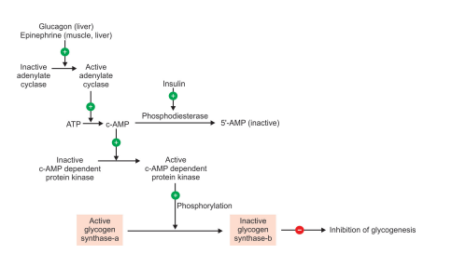
Figure 4: Hormonal regulation of glycogenesis

(ii) Regulation of glycogenolysis (Figure 5)
Glycogen phosphorylase is the regulatory enzyme of glycogenolysis. It exists in two forms: Glycogen phosphorylase-a, an active or phosphorylated form and Glycogen phosphorylase-b, an inactive or dephosphorylated form. Degradation of glycogen is stimulated by epinephrine in the muscle and by glucagon in the liver via activation of adenylate cyclase that catalyzes the synthesis of c-AMP. The consequent increase in levels of c-AMP, in turn, activates c-AMP dependent protein kinase. Active c-AMP dependant protein kinase phosphorylates the inactive form of phosphorylase kinase to its active form. Active phosphorylase kinase eventually activates inactive form of glycogen phosphorylase to its active form. The active form of glycogen phosphorylase stimulates breakdown of glycogen to glucose-1-P.
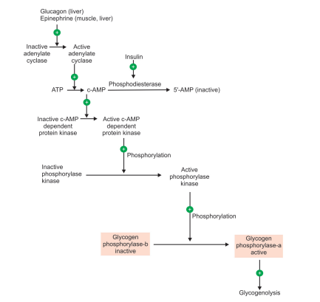
Figure 5: Hormonal regulation of glycogenolysis

(b) Allosteric Regulation (Figure 6)
Glycogen synthase is allosterically activated by glucose-6-phosphate when it is present in elevated concentrations. In contrast, glycogen phosphorylase is allosterically inhibited by glucose-6-phosphate. The Ca²⁺ ions stimulate glycogenolysis by activation of glycogen phosphorylase. An increased level of AMP in vigorously contracting muscles stimulates glycogen breakdown by stimulating glycogen phosphorylase allosterically. However, in resting muscles ATP inhibits the glycogen breakdown by allosteric inactivation of glycogen phosphorylase.
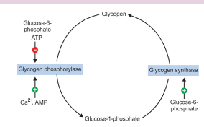
Figure 6: Allosteric regulation of glycogenesis and glycogenolysis
Assignment
Write briefly on glycogen storage disease
PENTOSE PHOSPHATE PATHWAY
The pentose phosphate pathway is an alternative route for the oxidation of glucose. It is the pathway for formation of pentose phosphate. It is also called hexose monophosphate shunt.
The difference between glycolysis and pentose phosphate pathway is shown in Table 12.5.
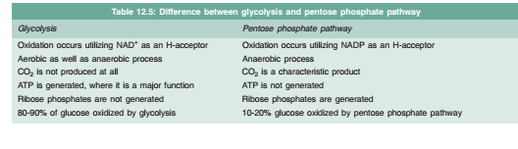
Characteristics of Pentose Phosphate Pathway
• It is a multicyclic process in which three molecules of glucose-6-phosphate give rise to three molecules of CO2 and three molecules of 5-carbon sugars, (ribulose-5-phosphate).
• The three molecules of ribulose-5-phosphate are arranged to generate two molecules of fructose-6-phosphate and one molecule of glyceraldehyde-3-phosphate.
• It does not generate ATP.
Location
The enzymes of pentose phosphate pathway are present in cytosol. The pathway is found in all cells.
Reactions of the Pentose Phosphate Pathway (Figure 7)
The reactions of the pathway are divided into two phases:
1. Phase I : Oxidative irreversible phase
2. Phase II: Nonoxidative reversible phase.
(1) Reactions of phase I (oxidative irreversible phase)
In the first phase, glucose-6-phosphate undergoes dehydrogenation and decarboxylation to give pentose, ribulose-5-phosphate with generation of NADPH.
1. Dehydrogenation of glucose-6-phosphate to 6-phosphogluconolactone, catalyzed by glucose- 6-phosphate dehydrogenase which is an NADP dependent enzyme.
2. 6-phosphogluconolactone is hydrolyzed by 6- phosphogluconolactone hydrolase to 6-phosphogluconate.
3. The subsequent oxidative decarboxylation of 6-phosphogluconate is catalyzed by 6- phosphogluconate dehydrogenase, which also requires NADP as hydrogen acceptor. This irreversible reaction produces ribulose-5- phosphate, CO2 and second molecule of NADPH.
(ii) Reactions of phase II (nonoxidative, reversible phase)
In the second phase, ribulose-5-phosphate is converted to fructose-6-phosphate by a series of reactions.
4. Ribulose-5-phosphate formed in the phase I now serves as substrate for two different enzymes:
i. Ribulose-5-phosphate epimerase catalyzes the epimerization of ribulose-5-phosphate to xylulose-5-phosphate.
ii. Ribulose-5-phosphate isomerase catalyzes the isomerization of ribulose-5-phosphate to ribose-5-phosphate.
5. Transketolase catalyzes the transfer of two-carbon units from xylulose-5-phosphate to ribose-5-phosphate, producing a 7-carbon, sedoheptulose-7-phosphate and glyceraldehyde-3-phosphate. The reaction requires coenzyme thiamine pyrophosphate (TPP) and Mg²⁺ ions.
6. Transaldolase catalyzes the transfer of a three carbon dihydroxyacetone group from sedoheptulose-7-phosphate to glyceraldehyde-3-phosphate to form fructose-6-phosphate and the 4- carbon, erythrose-4-phosphate.
7. Further reaction again involves transketolase, which catalyzes the transfer of the two carbon units from xylulose-5-phosphate to erythrose-4- phosphate producing fructose-6-phosphate and glyceraldehyde-3-phosphate.
8. Fructose-6-phosphate and glyceraldehyde-3- phosphate can be further catabolized through glycolysis and citric acid cycle.
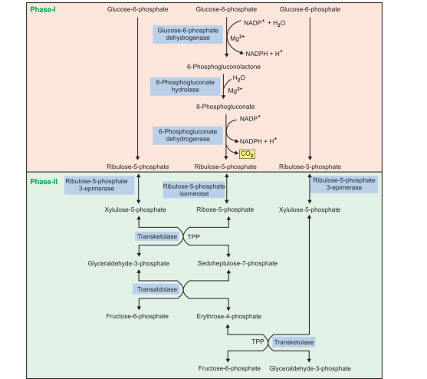
Figure 7: Pentose phosphate pathway, where, TPP: Thiamine pyrophosphate

Significance of Pentose Phosphate Pathway
• The pentoses (ribose-5-phosphate) required for the biosynthesis of nucteotide and nucleic acids (RNA and DNA) are provided by pentose phosphate pathway.
• It provides a route for the interconversion of pentoses and hexoses.
• It generates NADPH which plays important role in several other biological processes, as follows
– NADPH is required for the biosynthesis of fatty acids, cholesterol, steroid hormones and
neurotransmitters.
– It is required for oxidation-reduction reactions involved in detoxification, e.g. for detoxification of drugs by microsomal cytochrome P450 mono-oxygenase and for reduction of oxidized glutathione.
– In RBC, NADPH is required to maintain the level of reduced glutathione. The reduced
glutathione protects the RBC membrane from toxic effect of H₂O₂ by reducing H₂O₂ to H₂O
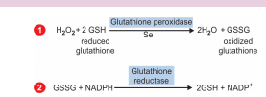
– NADPH also keeps iron of hemoglobin in reduced ferrous (Fe²⁺) state and prevents the formation of methemoglobin.
– NADPH is necessary for phagocytosis carried out by white blood cells.
Regulation of Pentose Phosphate Pathway
• The first step in the pathway, catalyzed by glucose- 6-phosphate dehydrogenase (G-6-PD) is the rate
limiting step.
• The activity of this enzyme is regulated by cellular concentration of NADPH. NADPH is a competitive
inhibitor of the enzyme G-6-PD.
• An increased concentration of NADPH decreases the activity of G-6-PD, for example:
– Under the well-fed condition, the level of NADPH decreases and pentose phosphate pathway is stimulated.
– However, in starvation and diabetes, the level of NADPH is high and inhibits the pathway.
• Insulin is also involved in the regulation of pentose phosphate pathway. It enhances the pathway by inducing the enzyme G-6-PD and 6-phosphogluconolactone dehydrogenase.
Assignment
- Write briefly on disorders of Pentose Phosphate Pathway
- Write comprehensively on Calvin Pathway
- Explain isolation, purification and structural determination of polysaccharides

