**BCH 201: General Biochemistry 1 3 Units (Dr O.B. Adewale)**

**CHEMISTRY OF CARBOHYDRATES**

Carbohydrates, the most abundant biomolecules in nature. They are primarily composed of the elements **carbon, hydrogen** and **oxygen** in the ratio (CH2O), hence the name "hydrate of carbon." They are a direct link between solar energy and the chemical bond energy of living organisms. They are formed during photosynthesis. **Carbohydrates can be defined as polyhydroxyaldehydes or ketones or compounds which produce them on hydrolysis.** The term ‘sugar’ is applied to carbohydrates soluble in water and sweet to taste.

**Functions of Carbohydrates**

Carbohydrates have a wide range of functions.

1. They are the most abundant dietary source of energy for all organisms, e.g. glucose.
2. Serve as storage form of energy, e.g. glycogen in animal tissue and starch in plants, to meet the immediate energy demands of the body.
3. They are structural components, e.g. glycosaminoglycans in human, cellulose in plants, exoskeleton (chitin) in insects and cell wall of microorganisms.
4. Non-digestable carbohydrates like cellulose, agar, gum and pectins serve as dietary fibres.
5. They are constituent of nucleotide that form RNA and DNA, e.g. ribose and deoxyribose sugar. The conformational flexibility of these sugar rings is important in the storage and expression of genetic information.
6. They are precursors for many organic compounds (fats, amino acids).
7. They play important role in lubrication, cellular intercommunication and immunity.
8. Carbohydrate, e.g. glycoprotein and glycolipid units on cell surfaces are key participants in cell to cell recognition during development.
9. They are involved in detoxification ,e.g. glucuronic acid
10. They are constituents of compound lipids and conjugated proteins

**Classification of Carbohydrates**

Carbohydrates are often referred to as saccharides (*Greek*: sakcharon – sugar). They are broadly classified into three groups - monosaccharides, Oligosaccharides, and Polysaccharides, and the categorization is based on the number of simple sugar units they contain. Mono- and oligo- saccharides are sweet to taste, crystalline in character and soluble in water, hence they are commonly known as sugars.

**MONOSACCHARIDES**

Monosaccharides or simple sugars are the simplest group of carbohydrates. They have the general formula CnH2nOn, and they cannot be further hydrolysed.

They are divided into different categories, based on the functional group and the number of carbon atoms.

Monosaccharides with an aldehyde functional group are called aldoses, e.g. glyceraldehydes, glucose, whereas those with a ketone group are called ketoses, e.g. dihydroxyacetone, fructose.



Based on the number of carbon atoms, the monosaccharides are regarded as trioses (contain 3 carbon atoms), tetroses (4C), pentoses (5C), hexoses (6C) and heptoses (7C). The most abundant monosaccharides found in living cells are the pentoses and hexoses. Often, class names such as aldohexoses and ketopentoses, which combine information about carbon number and functional groups, describe monosaccharides. For example, glucose is referred to as an aldohexose while fructose as a ketohexose.



**STRUCTURES OF MONOSACCHARIDES**

The sugar structures are known as Fischer projections (in honor of the great Nobel prize-winning German chemist Emil Fischer).

In these structures the carbohydrate backbone is drawn vertically with the most highly oxidized carbon usually shown at the top. The horizontal lines are understood to project toward the viewer, and the vertical lines recede from the viewer.

**MONOSACCHARIDE STEREOISOMERS**

Stereoisomerism is an important character of monosaccharides. Stereoisomers are the compounds that have the same structural formulae but differ in their spatial configuration. In optical isomers the reference carbon is the asymmetric carbon that is most remote from the carbonyl carbon. A carbon is said to be asymmetric when it is attached to four different atoms or groups. The number of asymmetric carbon atoms (n) determines the possible isomers of a given compound which is equal to 2n. Glucose contains 4 asymmetric carbons, and thus has 16 isomers.

Glyceraldehyde (triose) is the simplest monosaccharide with one asymmetric carbon atom. It exist as two stereoisomers and has been chosen as the reference carbohydrate to represent the structure of all other carbohydrates.

**D – and L – isomers**

The D and L isomers are mirror images of each other. The spatial orientation of –H and –OH groups on the carbon atom (C5 for glucose) that is adjacent to the terminal primary alcohol carbon determines whether the sugar is D – or L – isomer. If the –OH group is on the right side, the sugar is of D – series, and if on the left side, it belongs to L – series. They can be considered to be derived from either the triose D-glyceraldehyde (the aldoses) or the nonchiral triose dihydroxyacetone (the ketoses). The naturally occurring sugars in the mammalian tissues are mostly of D - configuration. The enzyme machinery of cells is specific to metabolise D – series of monosaccharides.



Stereoisomers of glucose

**OPTICAL ACTIVITY OF SUGARS**

Optical activity is a characteristic feature of compounds with asymmetric carbon atom. When a beam of polarized light is passed through a solution of an optical isomer, it will be rotated either to the right or left. The term dextrorotatory (+) and levorotatory (-) are used to compounds that respectively rotate the plane of polarized light to the right or to the left.

**EPIMERS**

If two monosacchariides differ from each other in their configuration around a single carbon (other than anomeric) atom, they are referred to as epimers of each other. E.g. glucose and galactose are epimers with regard to carbon 4 (C4-epimers). That is, they differ in the arrangement of –OH group at C4. Glucose and Mannose are epimers with regard to carbon 2 (C2-epimers). The interconversion of epimers is known as epimerization, and a group of enzymes that catalyse this reaction is called epimerases.



**ENANTIOMERS**

Enantiomers are a special type of stereoisomers that are mirror images of each other. The two members are designated as D – and L – sugars.



Enantiomers of glucose

Stereoisomers that are not enantiomers (mirror-image isomers) are called diastereomers. For example, the aldopentoses D-ribose and L-ribose are enantiomers, as are D-arabinose and L-arabinose.

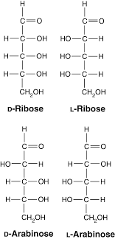

The sugars D-ribose and D-arabinose are diastereomers because they are isomers but not mirror images.



**CYCLIC STRUCTURES OF MONOSACCHARIDES**

Sugars that contain four or more carbons exist primarily in cyclic forms. Ring formation occurs in aqueous solution because aldehyde and ketone groups react reversibly with hydroxyl groups present in the sugar to form cyclic hemiacetals and hemiketals, respectively. Ordinary hemiacetals and hemiketals, which form when molecules containing an aldehyde or ketone functional group react with an alcohol, are unstable and easily revert to the aldehyde or ketone forms. When the aldehyde or ketone group and the alcohol functional group are part of the same molecule, however, an intramolecular cyclization reaction occurs that can form stable products. The most stable cyclic hemiacetal and hemiketal rings contain five or six atoms. As cyclization occurs, the carbonyl carbon becomes a new chiral center. This carbon is called the anomeric carbon atom.

The two possible diastereomers that may form during the cyclization reaction are called anomers. In aldose sugars the hydroxyl group of the newly formed hemiacetal occurs on carbon 1 (the anomeric carbon) and may occur either above the ring (in the "up" position) or below the ring (in the "down" position). When the hydroxyl is down, the structure is in the α-anomeric form. If the hydroxyl is up, the structure is in the β-anomeric form. In Fischer projections, the α-anomeric hydroxyl occurs on the right and the β-hydroxyl occurs on the left.



It is important to note that the anomers are defined relative to the D- and L-classification of sugars. These rules apply only to D-sugars, the most common ones found in nature. In the L-sugars the α-anomeric OH group is above the ring. The cyclization of sugars is more easily visualized by using Haworth structures.

**HAWORTH STRUCTURES**

Fischer representations of cyclic sugar molecules use a long bond to indicate ring structure. A more accurate picture of carbohydrate structure was developed by the English chemist W. N. Haworth.

Haworth structures more closely depict proper bond angles and lengths than do Fischer representations. To convert from the traditional Fischer formula of a D-pentose or D-hexose to a Haworth formula, the following steps should be followed:

1. Draw a five- or six-membered ring with the oxygen placed:

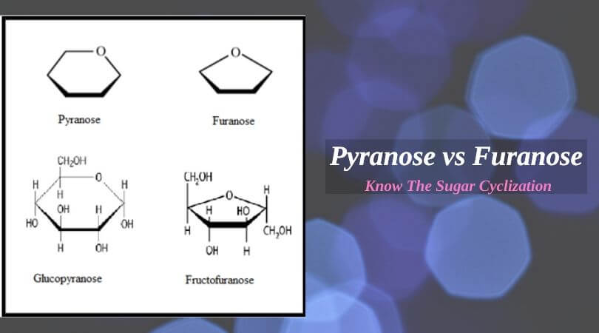 

Five-membered ring Six-membered ring

2. Starting with the anomeric carbon to the right of the ring oxygen, place hydroxyl groups either above or below the plane of the ring. Groups that are pointing to the left in the Fischer projection formula should go above the plane of the ring, and those that are pointing to the right in the Fischer projection formula should go below the ring.

3. In D-sugars, the last carbon position (e.g., C-6 glucose) is always up.

Five-membered hemiacetal rings are called furanoses because of their structural similarity to furan.

For example, the cyclic form of fructose is called fructofuranose. Six-membered rings are called pyranoses because of their similarity to pyran. Glucose, in the pyranose form, is called glucopyranose.



**OLIGOSACCHARIDES**

The term oligosaccharide is often used for relatively small sugar polymers that consist of two to ten or more monosaccharide units. When they are linked together by glycosidic bonds, monosaccharides form a variety of molecules that perform diverse biological functions. Among the oligosaccharides, disaccharides are the most common. Disaccharides are glycosides composed of two monosaccharides. If one monosaccharide molecule is linked through its anomeric carbon atom to the hydroxyl group on carbon 4 of another monosaccharide, the glycosidic linkage is designated as 1,4. Because the anomeric hydroxyl group may potentially be in either the α- or β-configuration, two possible disaccharides may form when two sugar molecules are linked: α-(l,4) or β-(l,4). Other varieties of glycosidic linkages (i.e., α or β-(1,1), (1,2), (1,3), and 1,6) linkages) also occur. Oligosaccharides are subdivided into different groups based on the number of monosaccharide units present. Oligosaccharides with more than three subunits are usually found bound as side chains in glycoproteins; such as blood group antigens.

Type of Oligosaccharide No of monosaccharide Example Type of monosaccharide present

Disaccharide Two Maltose Glucose + Glucose

Lactose Glucose + Galactose

Sucrose Glucose +Fructose

Trehalose Glucose + Gulose

Trisaccharide Three Raffinose Glucose + Galactose + Fructose

Tetrasaccharide Four Stachyose 2Galactose + Glucose + Fructose

Pentasaccharide Five Verbascose 3Galactose + Glucose + Fructose

Disaccharides are crystalline, water soluble and sweet to taste. They are of two types:

1. Reducing disaccharides with free aldehyde or keto group e.g. maltose, lactose.
2. Non-reducing disaccharides with no free aldehyde or keto group e.g. sucrose, trehalose.

**Lactose** (milk sugar) is a disaccharide found in milk. It is composed of one molecule of β-D- galactose linked through the hydroxyl group on carbon 1 in a glycosidic linkage (β (1→4)) to the hydroxyl group of carbon 4 of a molecule of β-D- glucose.

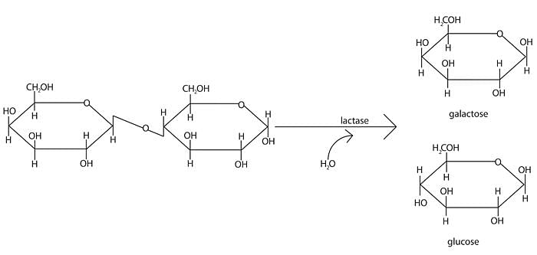 **Lactose**

The inability to hydrolyze the β-(1,4) linkage (caused by lactase deficiency) is common among animals, so carbohydrates with such linkages (such as cellulose) cannot be digested. Because the glucose component contains a hemiacetal group, lactose is a reducing sugar.

**Maltose**, also known as malt sugar, is an intermediate product of starch hydrolysis and does not appear to exist freely in nature. Maltose is a disaccharide with an α-(1,4) glycosidic linkage between two α- D-glucose molecules. In solution the free anomeric carbon undergoes mutarotation, which results in an equilibrium mixture of α- and β-maltoses.

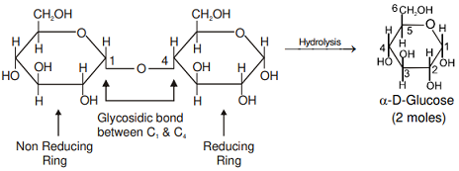

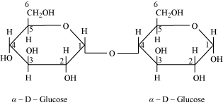**Maltose**

**Isomaltose:** The glucose units are held together by α (1→6) glycosidic linkage.

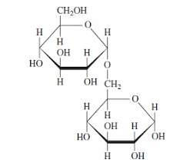 **Isomaltose**

**Cellobiose**, a degradation or hydrolytic product of cellulose, contains two molecules of glucose linked by a β (1→4) glycosidic linkage.

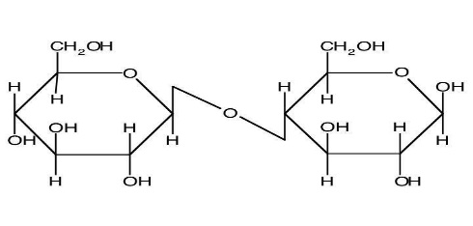 **Cellobiose**

Like maltose, whose structure is identical except for the direction of the glycosidic bond, cellobiose does not freely exist in nature.

**Sucrose** (common table sugar: cane sugar or beet sugar) is produced in the leaves and stems of plants. It is a transportable energy source throughout the entire plant. Containing α-D-glucose and β-D-fructose residues, sucrose differs from lactose and maltose in that the monosaccharides are linked through a glycosidic bond between both anomeric carbons (α1 → β1). The reducing groups of glucose and fructose are involved in glycosidic bond (also because neither monosaccharide ring can revert to the open chain form), hence sucrose is a non-reducing sugar.



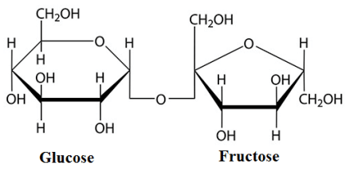 **Sucrose**

**POLYSACCHARIDES**

Polysaccharides (or simply glycans) consist of repeat units of monosaccharides or their derivatives, held together by glycosidic bonds. They are primarily concerned with two important functions – structural, and storage of energy. Polysaccharides are linear as well as branched polymers. This is contrast to structure of proteins and nucleic acids which are only linear polymers. The occurrence of branches in polysaccharides is due to the fact that glycosidic linkages can be formed at any one of the hydroxyl groups of a monosaccharide.

Polysaccharides are divided into two classes: homopolysaccharides and heteropolysaccharides

**HOMOPOLYSACCHARIDES**

Homopolysaccharides, which on hydrolysis yield only a single type of monosaccharide unit. The most abundant ones found in nature are starch, glycogen, cellulose, and chitin.

**STARCH:** Starch, the energy reservoir of plants, is a significant source of carbohydrate in the human diet. Much of the nutritional value of the world's major foodstuffs (e.g., potatoes, rice, corn, and wheat) comes from starch. It is composed of D-glucose units held by α-glycosidic bonds. It is known as glucosan or glucan. Two polysaccharides occur together in starch: water soluble amylose and a water insoluble amylopectin.

Amylose is composed of long, unbranched chains of D-glucose residues held by α (1→4) glycosidic linkages.

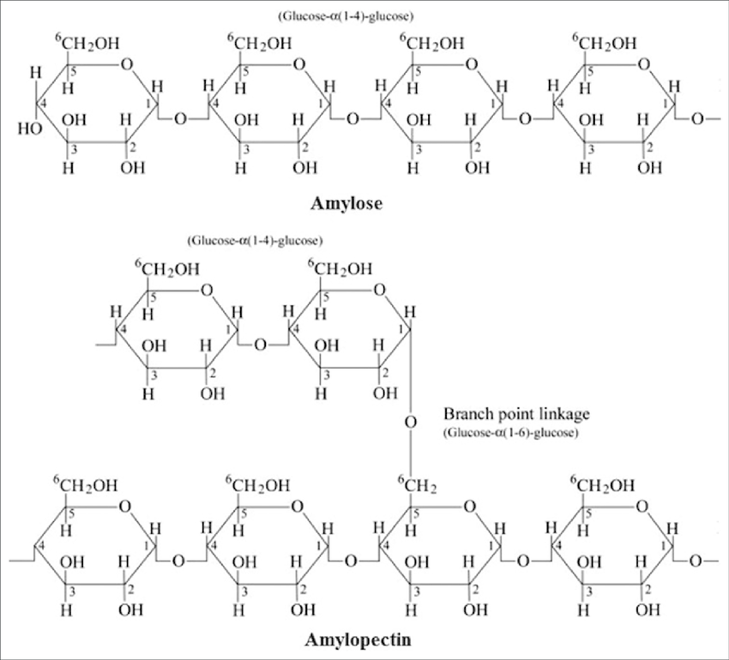

Amylopectin, is a branched polymer containing α (1→6) glycosidic bonds at the branched points and α (1→4) glycosidic linkages everywhere else. Starches are hydrolysed by amylase (pancreatic and salivary) to liberate dextrins, and finally maltose and glucose units. Amylase acts specifically on α (1→4) glycosidic bonds.



**GLYCOGEN**: Glycogen is the carbohydrate storage molecule in vertebrates. It is found in greatest abundance in liver and muscle cells. Glycogen is similar in structure to amylopectin except that it has more branch points, possibly at every fourth glucose residue in the core of the molecule. Glucose is the repeating unit in glycogen joined together by α (1→4) glycosidic bonds and α (1→6) glycosidic bonds at branching points.

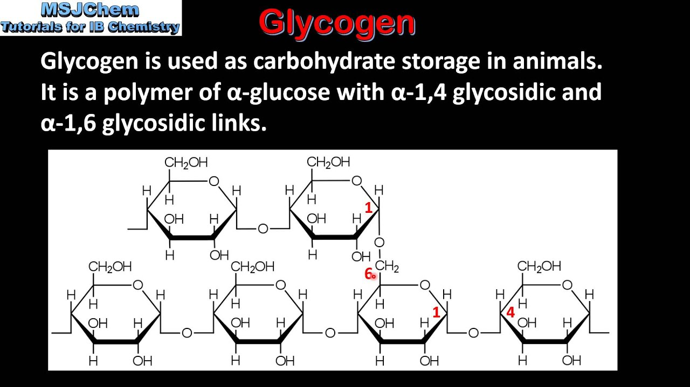 **Glycogen**

**CELLULOSE**

Cellulose is the primary structural component of plant cells. It is composed of β-D-glucose units linked by β (1→4) glycosidic bonds. Cellulose cannot be digested by mammals – including man – due to lack of the enzyme that cleaves β-glycosidic bonds (α amylase breaks α bonds only). Certain ruminants and herbivorous animals contain microorganisms in the gut which produce enzymes that can cleave β-glycosidic bonds. Hydrolysis of cellulose yields a disaccharide cellobiose, followed by β-D-glucose.

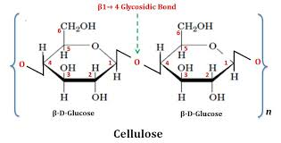

The ability to digest cellulose is found only in microorganisms that possess the enzyme cellulase. Although many animals cannot digest cellulose-containing plant materials, these substances play a vital role in nutrition. Cellulose is one of several plant products that make up the dietary fiber whose functions include decreasing the absorption of glucose and cholesterol from the intestine, besides increasing the bulk of feaces.

**CHITIN**: It is composed of N-acetyl-D- glucosamine units held together by β (l→4) glycosidic bonds. It is a structural polysaccharide found in the exoskeleton of some invertebrates e.g. insects, crustaceans.

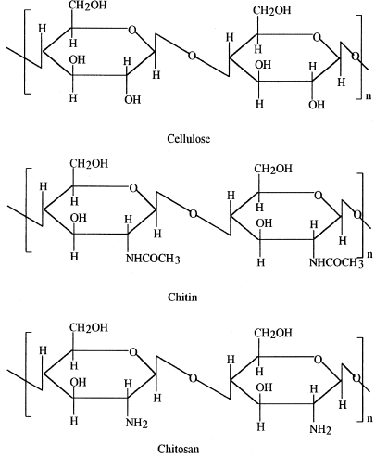

**HETEROPOLYSACCHARIDES**

Heteropolysaccharides are high-molecular-weight carbohydrate polymers that contain more than one kind of monosaccharide. Important examples include the glycosaminoglycans (GAGs), the principal components of proteoglycans, and murein, a major component of bacterial cell walls.

**GLYCOSAMINOGLYCANS**: GAGs are linear polymers with disaccharide repeating units. Many of the sugar residues are amino derivatives.

The repeating units contain a hexuronic acid (a uronic acid containing six carbon atoms), except for keratan sulfate, which contains galactose. Usually an

N-acetylhexosamine sulfate is also present, except in hyaluronic acid, which contains N-acetylglucosamine. Many disaccharide units contain both carboxyl and sulfate functions groups. GAGs are classified according to their sugar residues, the linkages between these residues, and the presence and location of sulfate groups. Five classes are distinguished: hyaluronic acid, chondroitin sulfate, dermatan sulfate, heparin and heparan sulfate, and keratan sulfate.

**MUREIN**: Murein, also referred to as peptidoglycan, is a complex polymer that is the major structural feature of the cell walls of all bacteria. It contains two sugar derivatives: N-acetyl-glucosamine and N-acetyl-muramic acid [N-acetyl-glucosamine bonded to lactic acid (CH3CH(OH)COOH) by an ether linkage], and several different amino acids (some of which are D-isomers). Murein consists of three basic components: a backbone composed of disaccharide repeating units linked by β(l,4) glycosidic bonds, parallel tetrapeptide chains, each of which is attached to N-acetyl-muramic acid, and a series of peptide cross-bridges that form between the tetrapeptide chains of parallel polysaccharide backbones. Murein is largely responsible for the shape and the rigidity of bacterial cell walls.

**Study questions**

1. Define and classify carbohydrates with suitable examples and structures. Add a note on the functions of carbohydrates.
2. Give an account of the structural configuration of monosaccharides, with special reference to glucose.
3. Discuss the structure and functions of 3 biochemically important disaccharides.
4. Write short notes on: a) Epimers b) Anomers c) Mutarotation d) Enantiomers
5. With relevant examples and structures, classify polysaccharides.